Dutch Oven Gorilla Bread

Ingredients:
1/2 cup sugar
3 t cinnamon
1/2 cup (1 stick) butter cut into approx 1/4 inch cubes
1 cup packed brown sugar
8 oz cream cheese
2 - 12 oz cans refrigerator biscuits (8 - 10 per can)

Directions:
Start coals in charcoal chimney. Should start about 40 - 45 coals. (One or two people can do this.)
While coals are heating:
Line Dutch Oven with parchment paper (should look like a giant coffee filter) and place buttered (so dough won’t stick to it) empty can in center (so it will be like a bundt pan.) (One or two people can do this.)
Mix together cinnamon and white sugar in a ziplock bag. Set aside. (One or two people can do this.)
Mix together cubed butter and brown sugar in a ziplock bag. Kneed butter into sugar until it’s crumbly. Set aside. (One or two people can do this.)
Cut cream cheese into 18 cubes. (One or two people can do this.)
Open biscuit dough. Press out each biscuit with hands until each is about 4.5 inch in diameter then sprinkle with 1/2 teaspoon of the cinnamon sugar. Place a cube of cream cheese in the center of each, then wrap and seal the dough around the cream cheese.
Place 8 biscuits “seam side up” in Dutch Oven.
Sprinkle with half of the butter brown sugar mixture.
Top with remaining 8 biscuits, then sprinkle with remaining butter brown sugar mixture, then sprinkle with remaining cinnamon sugar mixture.

Put lid on Dutch Oven. Place 15 coals in circle pattern (with some coals on the outside of the circle and some on the inside) and set Dutch Oven on coals. Place 18 coals on top of lid. Cook for approximately 30 - 45 minutes.
Make sure you have more hot coals ready if you need more. Periodically, tap coals on lid to knock away ash. (The ash actually insulates the coal, keeping heat in. Knocking the ash off will allow the heat to transfer to the Dutch Oven surface better.) QUICKLY feel the sides of the Dutch Oven to make sure the sides are very hot. On cold and windy days you will need more coals to get the oven to the right temperature.
After 30 minutes, QUICKLY AND CAREFULLY lift the lid of the Dutch Oven to check cooking. Bread should look done and brown and liquid should be bubbly. Cook longer and/or add more coals if needed.

When done, remove from heat and remove lid. Take can out of center and spoon excess liquid over buns. Let cool for about 5 minutes. Carefully lift parchment out of Dutch Oven and place on serving plate.
Bottom ones are best so take one of those to judges!

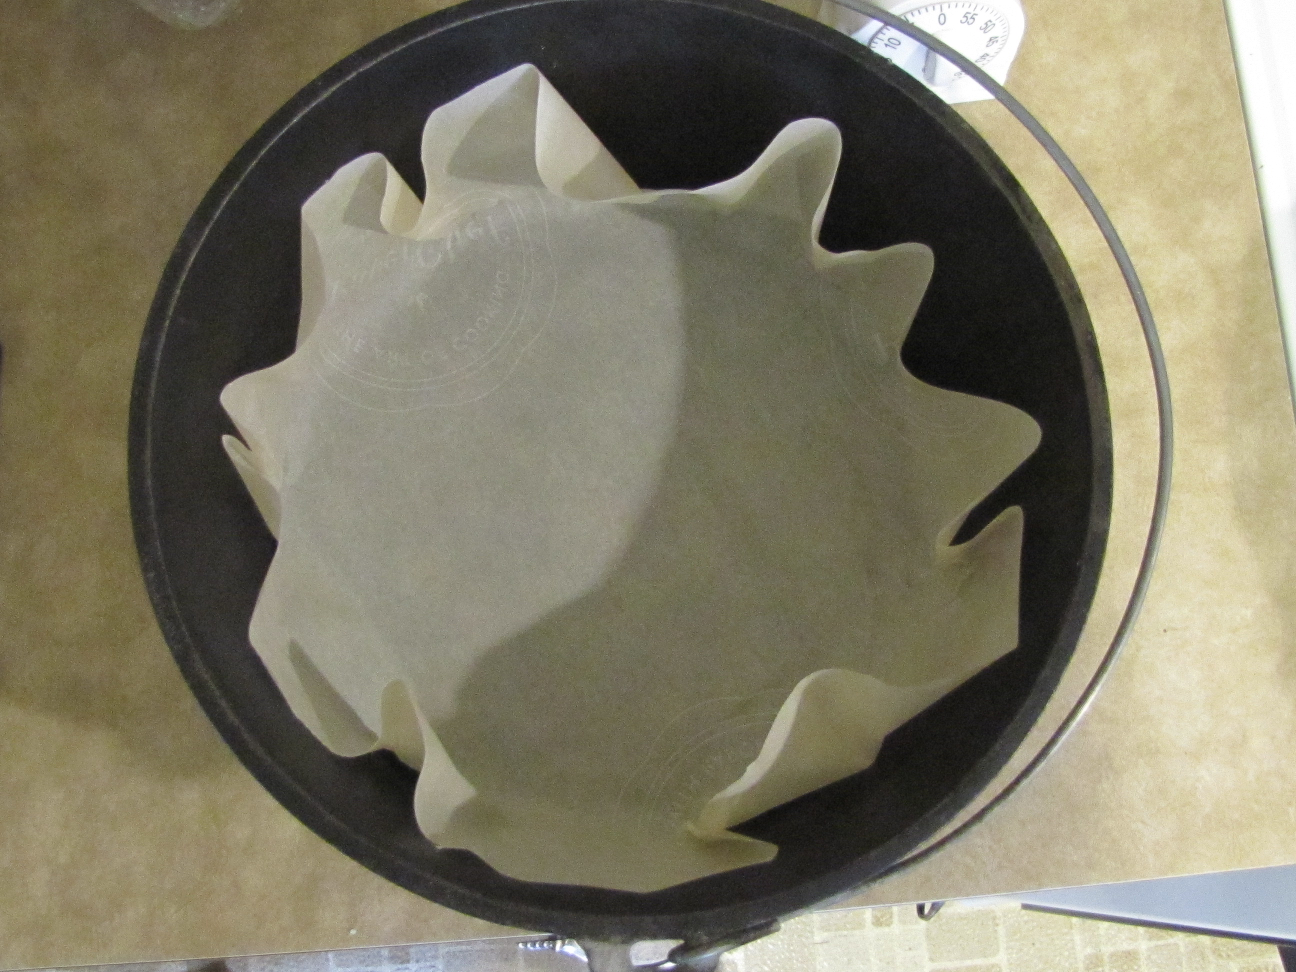  Parchment paper liner in Dutch Oven | 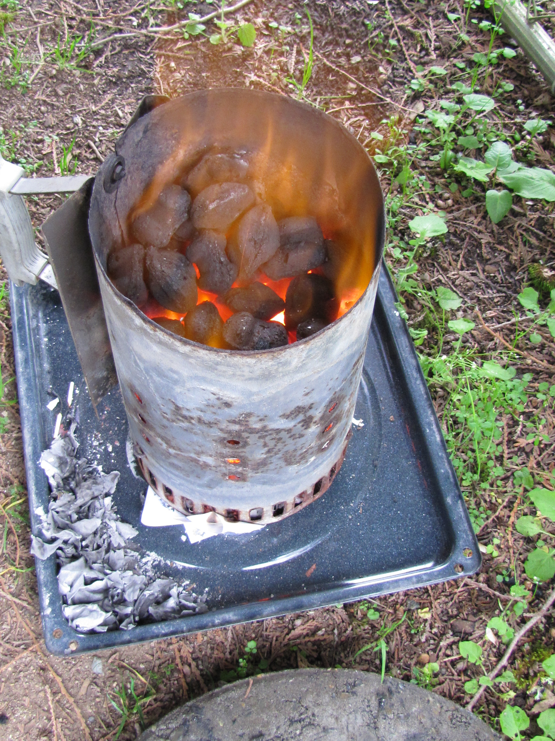  Coals heating in charcoal chimney
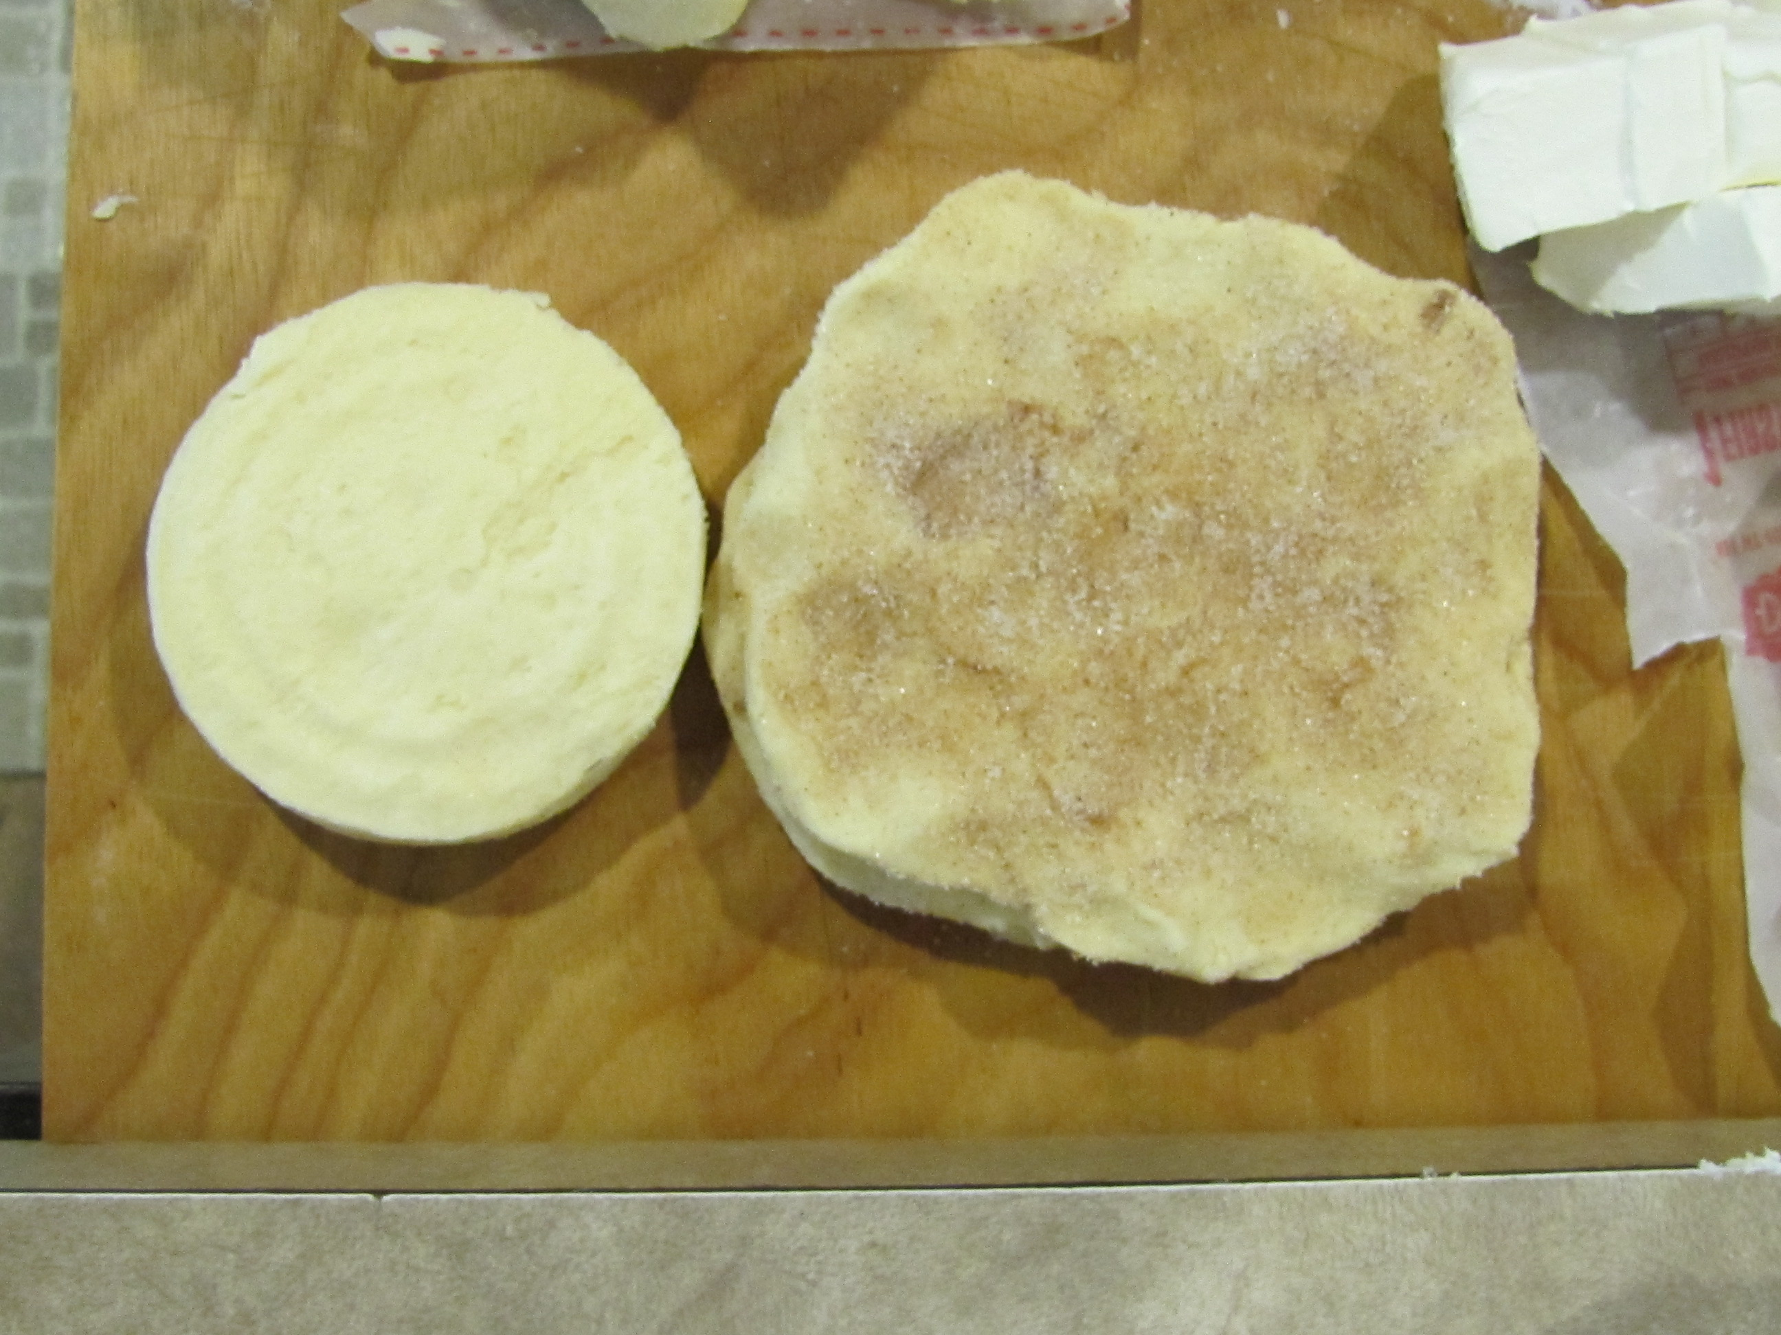  Biscuit straight out of can, and one stretched out | 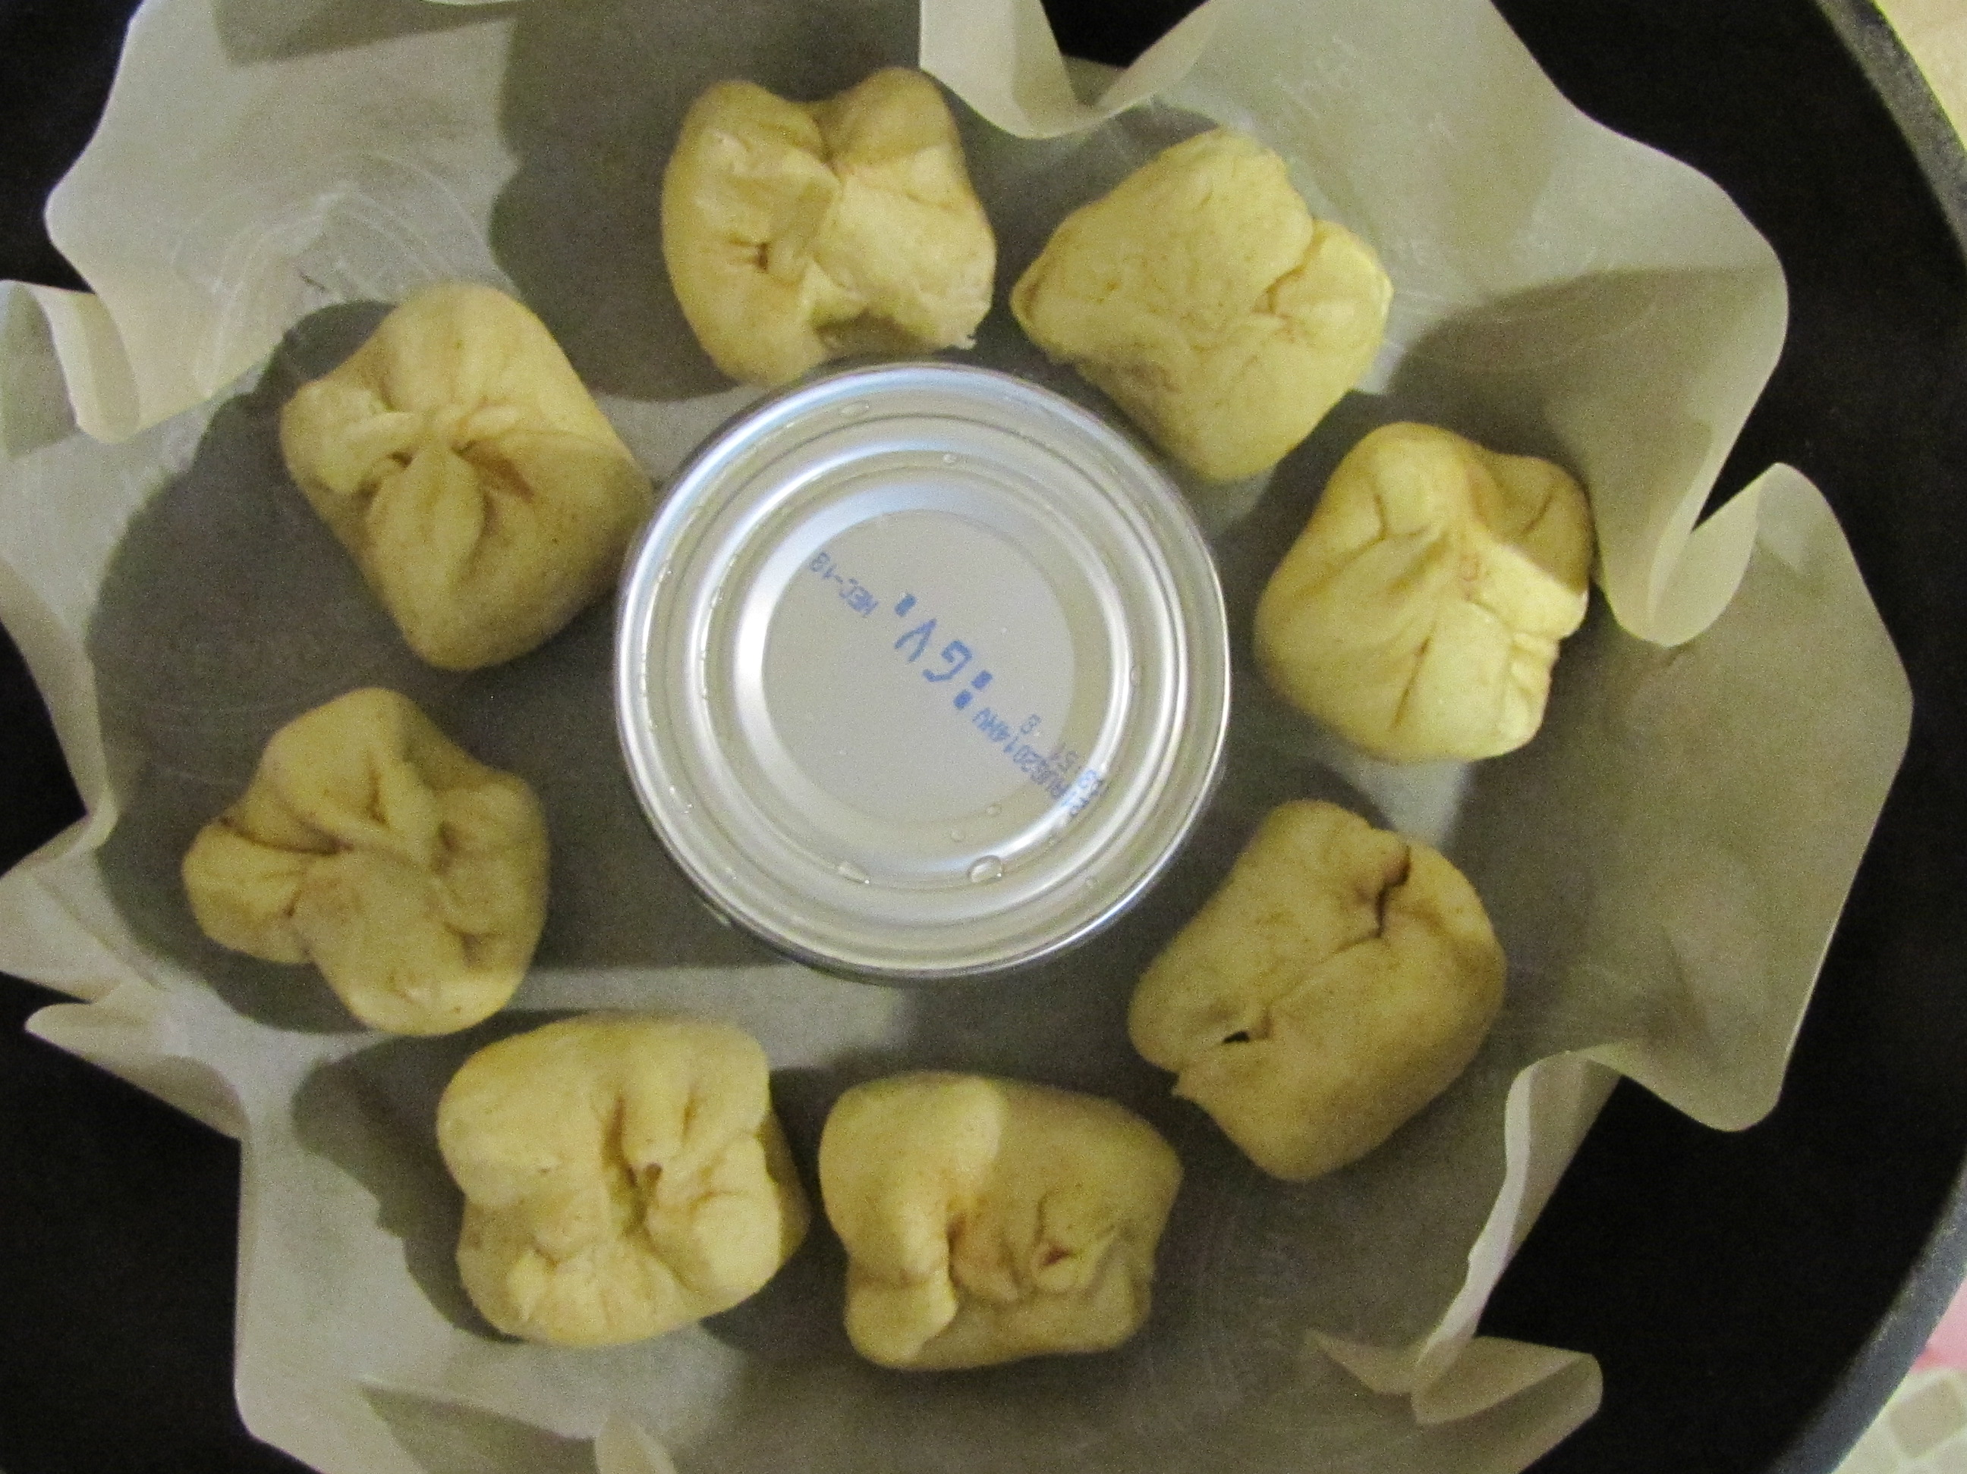  1st layer of biscuits filled with cream cheese
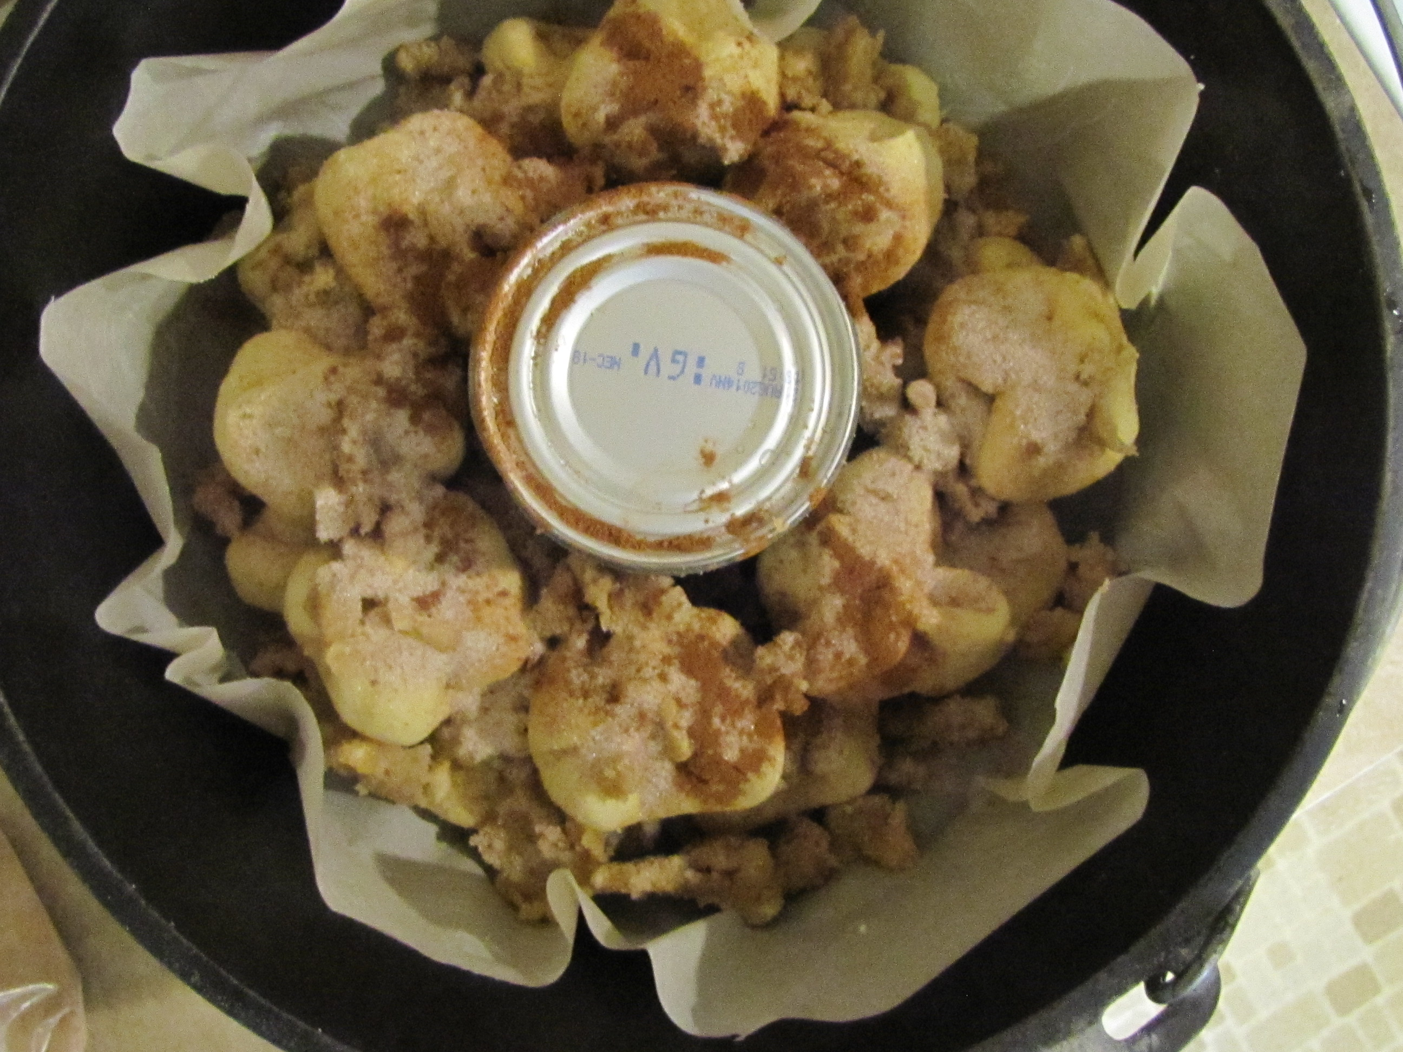  All ready to bake! | 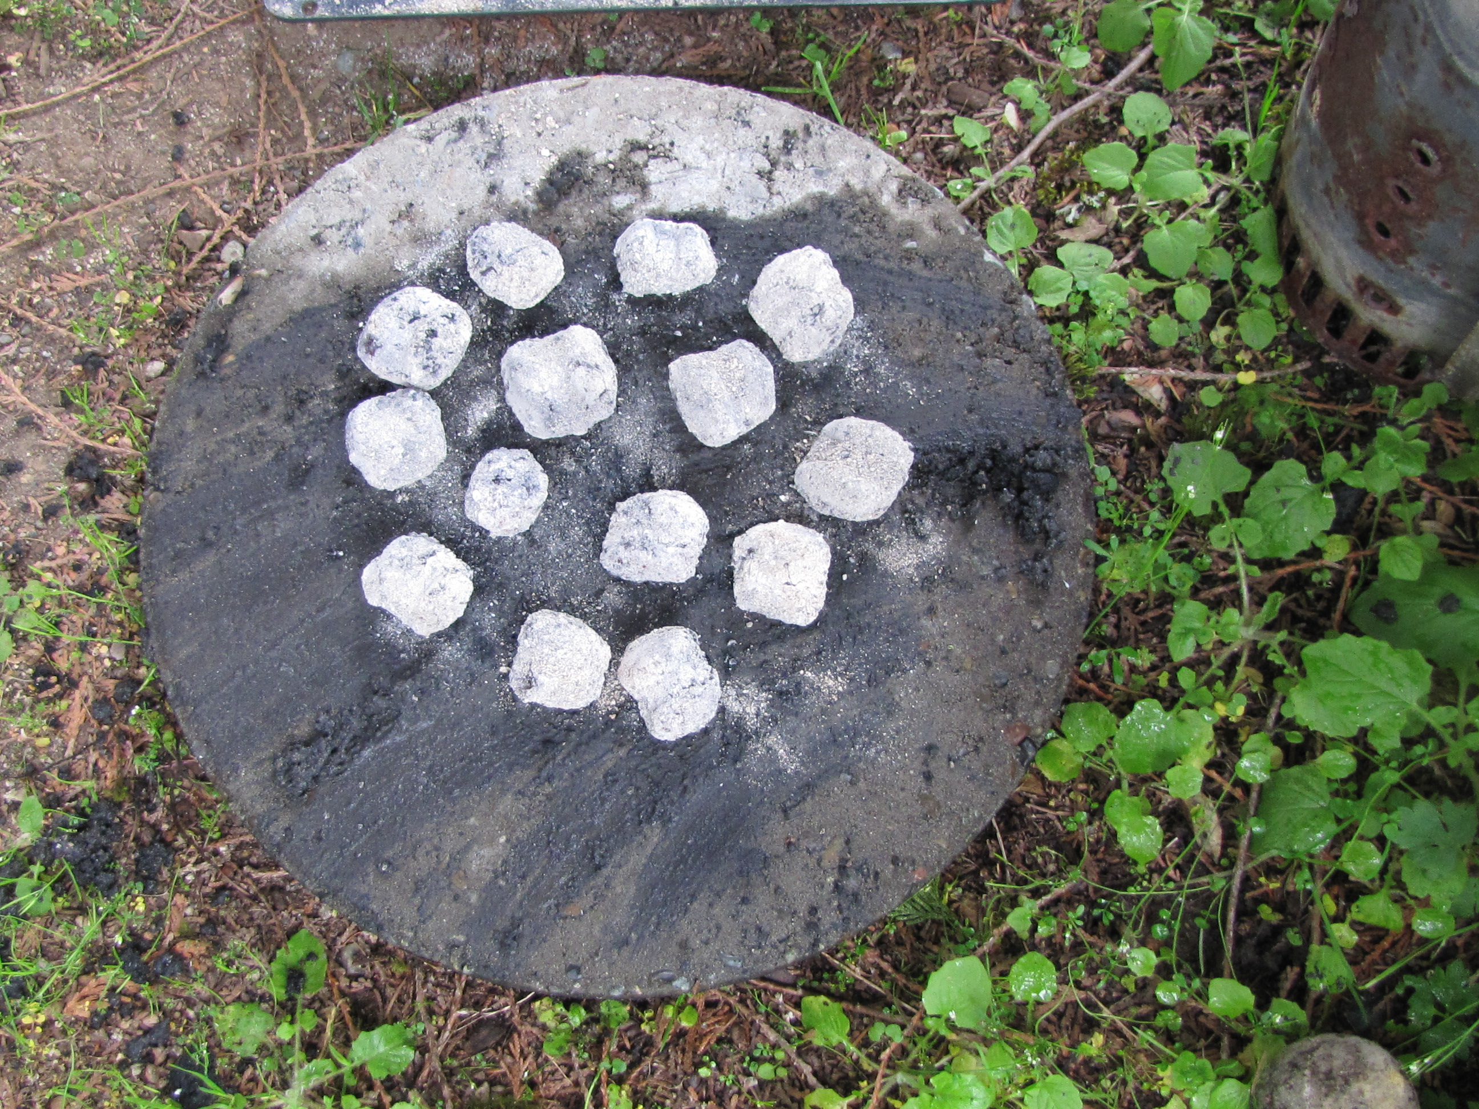  Coals on ground ready to set on Dutch Oven
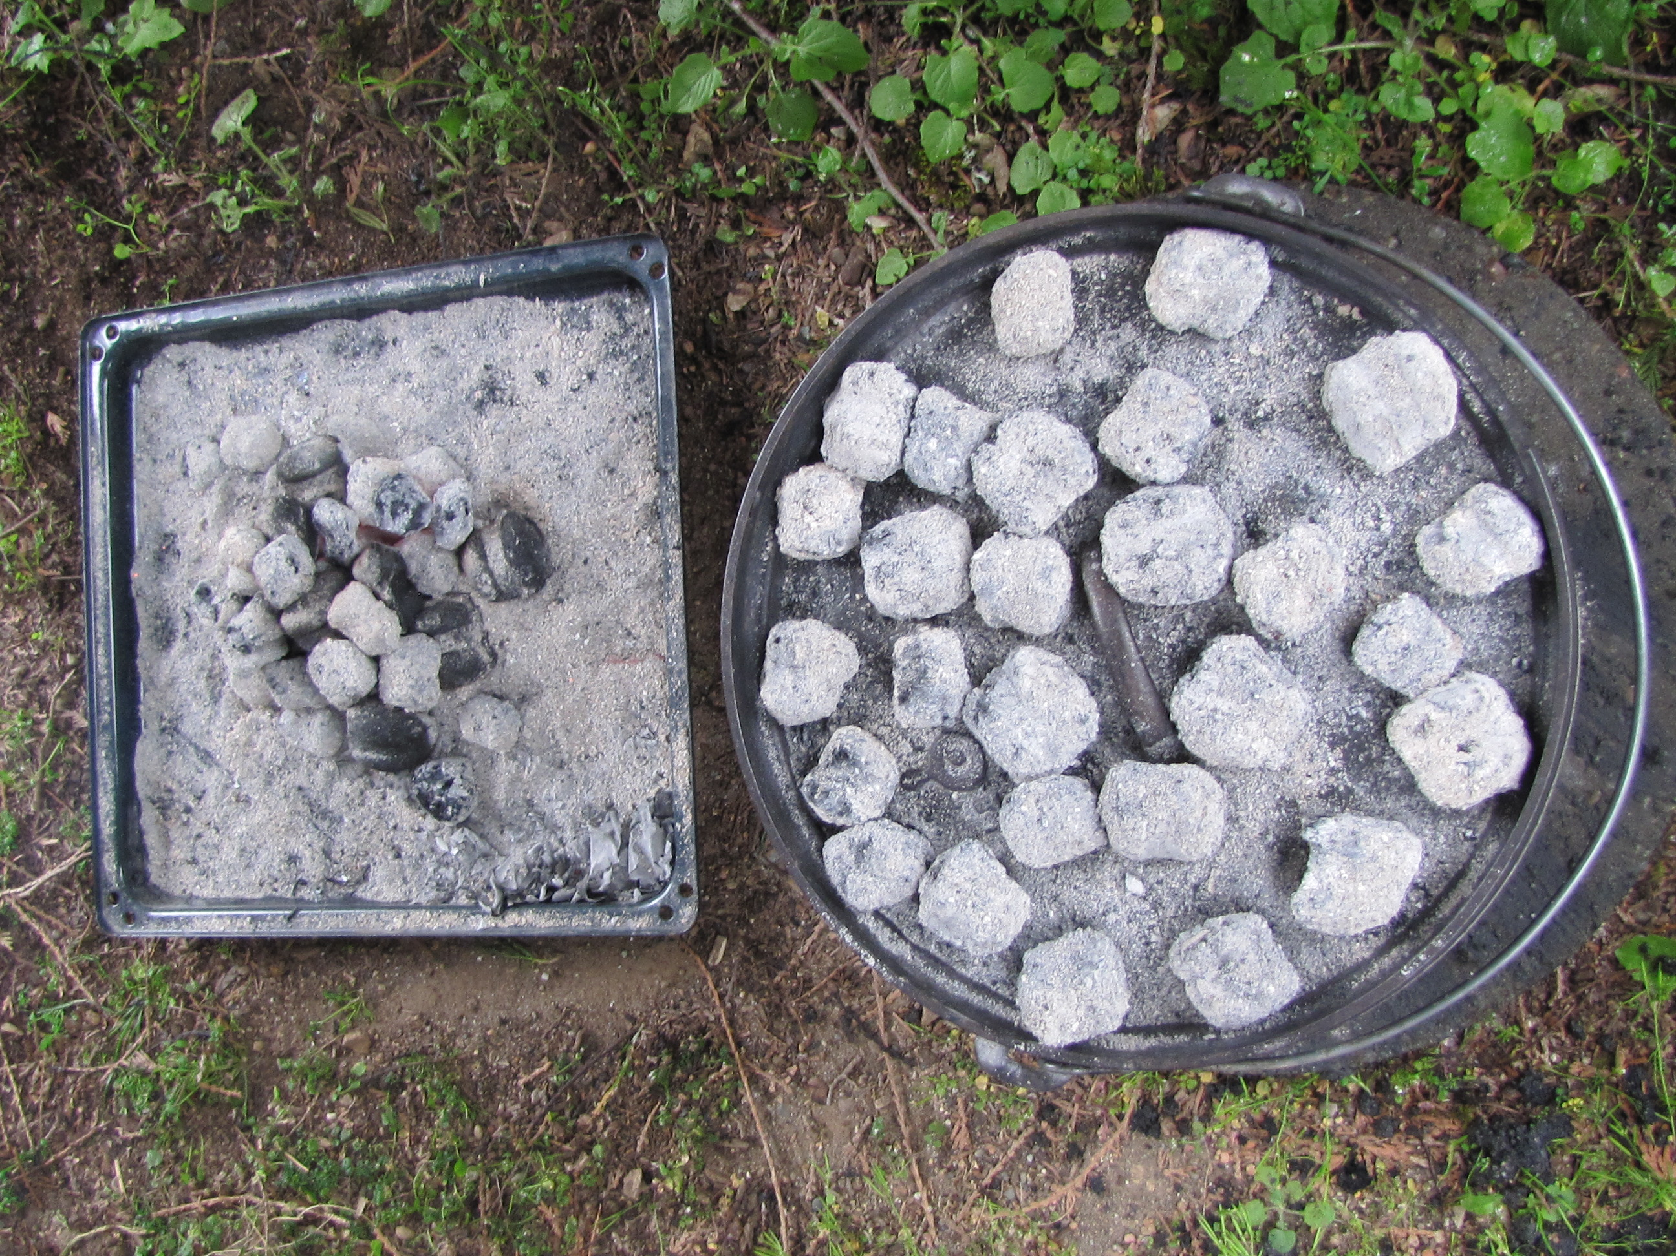  Coals on top of Dutch Oven and more coals ready | 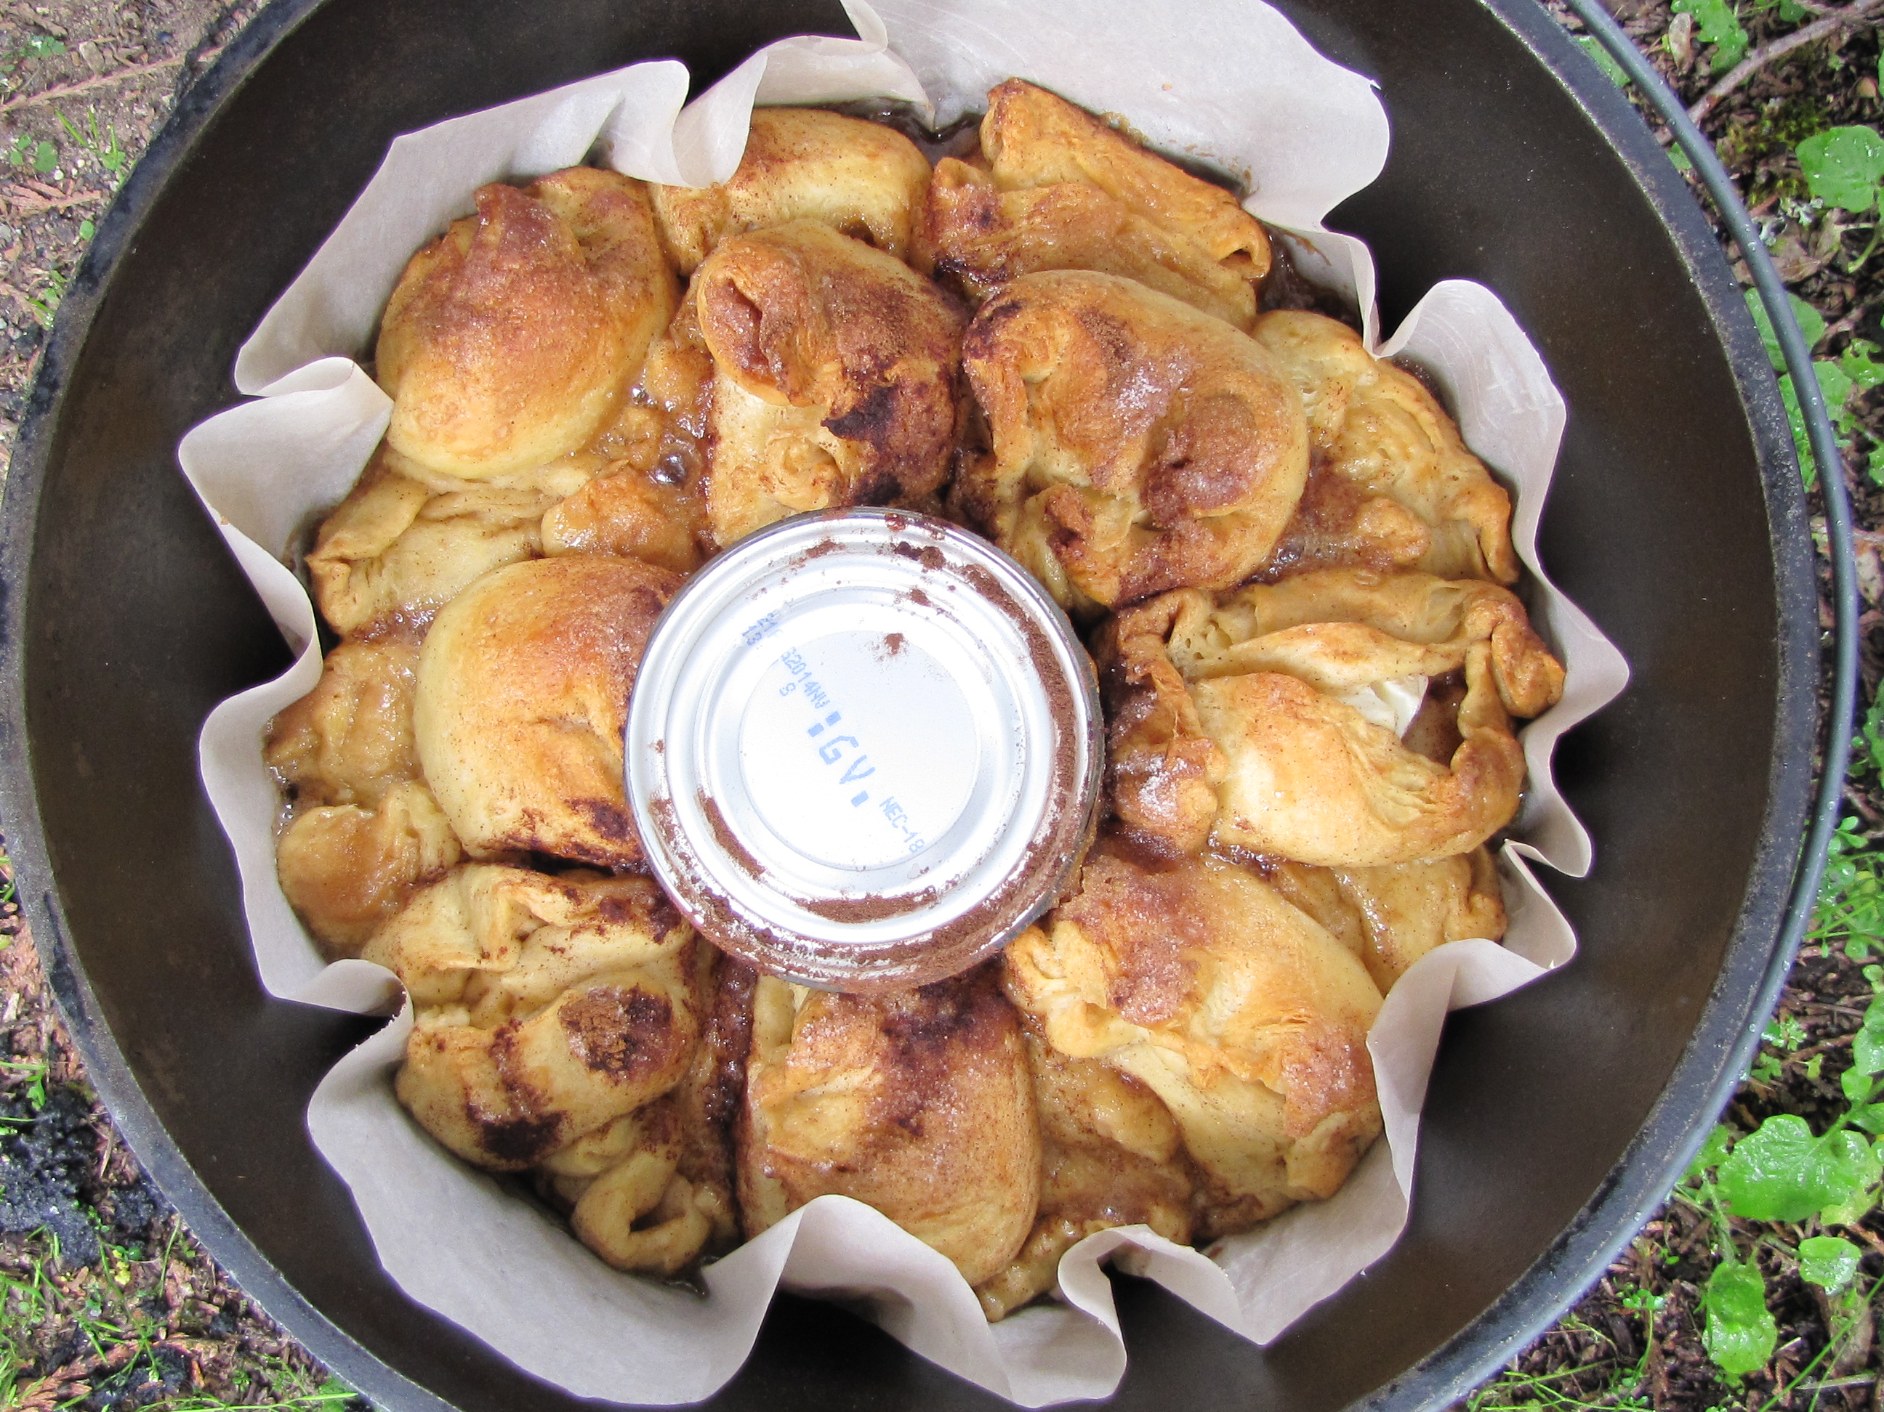  Finished baking!
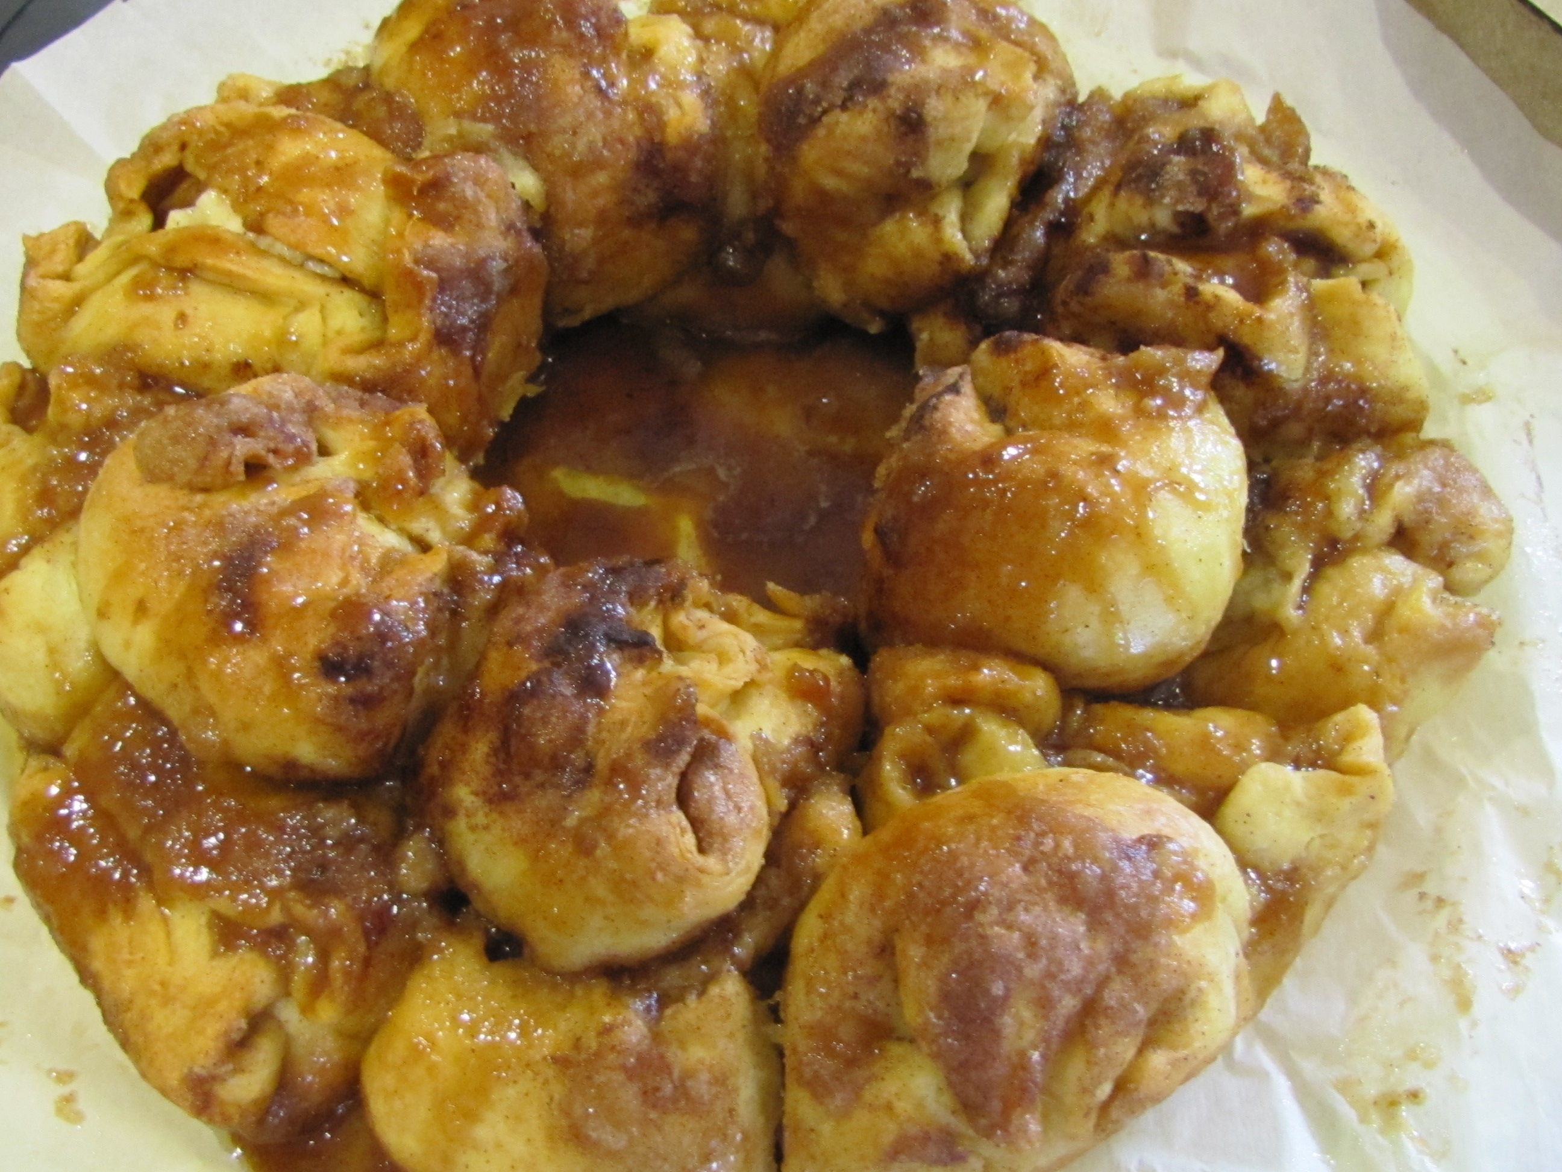 Ready to eat!

